**Portfolio Website Project: Report   
Github: https://github.com/Birkbeck2/canary-portfolio-website-olootu**

**Background**This Portfolio website is part of assignments to demonstrate the skills and knowledge that I have gained from the PGCert Web Development & User Experience course. The choice of content and design are solely mine, but it is expected that I demonstrate all the key aspects covered in the different sessions of the course.

**Decisions & Thoughts**I made the decision to build a simple four-page portfolio website of Classical and Vintage cars. The aim of the portfolio website is not really for visual appeal but to showcase the fundamentals of accessible website that conforms to the WCGA guideline and web standards. The website will have the following four (4) pages:

**Classical cars:** This is the home page, and it will show a list of a photo gallery of Classical cars.

**Vintage cars:** This page will show a list of Vintage cars in a photo gallery.

**About: I** will use this page to show case myself, highlight my background and my frontend skills.

**Contact:** This is a very simple contact page that will contain a contact-me form that a user can use to reach me.  
  
**Design Approach & Users**

The target audience will be the public, my fellow students, Tutors and assignment markers. The website is intended to be used by regular users as well as users with disability.  
For the Design Approach, I decided to follow the Extreme Programming (XP) approach. The reason for this is because my portfolio website is a small project, I am the sole developer working on the project, therefore, I believe using other approaches like the Waterfall and User-Centred designs will be an overkill.   
The usual long and detailed documentation and heavy cost involved in other design approaches would be avoided with the choice of Extreme Programming (XP).

T.Sedano and Ji, whilst describing Extreme Programming (XP) said that “Methodologists often describe Extreme Programming as the stereotypical agile method.” (Ji and T. Sedano, 2011. [Comparing extreme programming and Waterfall project results](https://moodle.bbk.ac.uk/pluginfile.php/3049174/mod_label/intro/Comparing_extreme_programming_and_Waterfall_projec.pdf)).

### **Accessibility** One of the aims of this project is to build a website that is accessible to all users, especially people with disabilities and that also complies with the four (4) core principle of the Web Content Accessibility Guidelines (WCAG 2), i.e. to be **Perceivable**, **Adaptable**, **Adaptable** and **Operable** (<https://www.w3.org/TR/WCAG21/>).

To make the website accessible, semantic HTML were used as appropriate so that the website is usable for screen readers and keyboard navigation.  
  
**Accessibility Tests**

The website was thoroughly tested using the following tools and browser plugins:

1. Wave (browser plugin)
   1. **Result:** All sections passed with zero errors
2. Lighthouse (browser plugin)
   1. **Result:** All pages passed accessibility test with 100% pass rate
3. W3C HTML Validation
   1. **Result:** Passed with no errors
4. W3C CSS Validation
   1. **Result:** Passed with no errors

All validation test results are attached later in this document.

**Layout & Structure**

**Page Layout:** The layout is a simple three (3) column/row Grid layout of Header, Main and Footer.

**Header:** The header will contain a four navigation items that will be semantically coded using the header and the nav elements/tags accordingly. The navigation itself uses the grid layout to make it responsive for both the mobile devices as well as larger screens.  
  
**Navigation:** The site has a four-item navigation; Classical cars, Vintage cars, About and the Contact. It is a simple horizontal navigation for the desktop and large screens. For the mobile phones, it is vertical. I chose this type of navigation based on the different examples that I found on the internet. It looks more convectional, in my opinion.  
  
I also included the same navigation in the footer for the desktop version. This is for useability reasons as users would not have to scroll back to the top to navigate away from the page.

The footer navigation is removed from the mobile version to conserve space.

**Main:** This is the main content area that will hold all the page contents.

**Footer:** The Footer, just like the Header, will hold another 4-item-navigation. The reason for having the bottom footer is for usability purpose; users won’t have to scroll back to the top page, in situations where the main content area is long, if they needed to navigate to other pages.

**Typography**I have selected the Google fonts *Roboto* and *Audiowide.*

**Roboto:** I chose the Roboto font because it is well used on the internet. It was claimed, in the m3.material article that it is the most popular downloaded font (https://m3.material.io/blog/roboto-flex).

**Audiowide: I** love the decorative style of this font. I will be using it for the headings of the website.

**Colour & Contrast**To have enough contrast between the background and the text, I choice two (2) colour scheme for all the pages:  
Background: Black (#000000)

Text Colour: White (#FFFFFF)

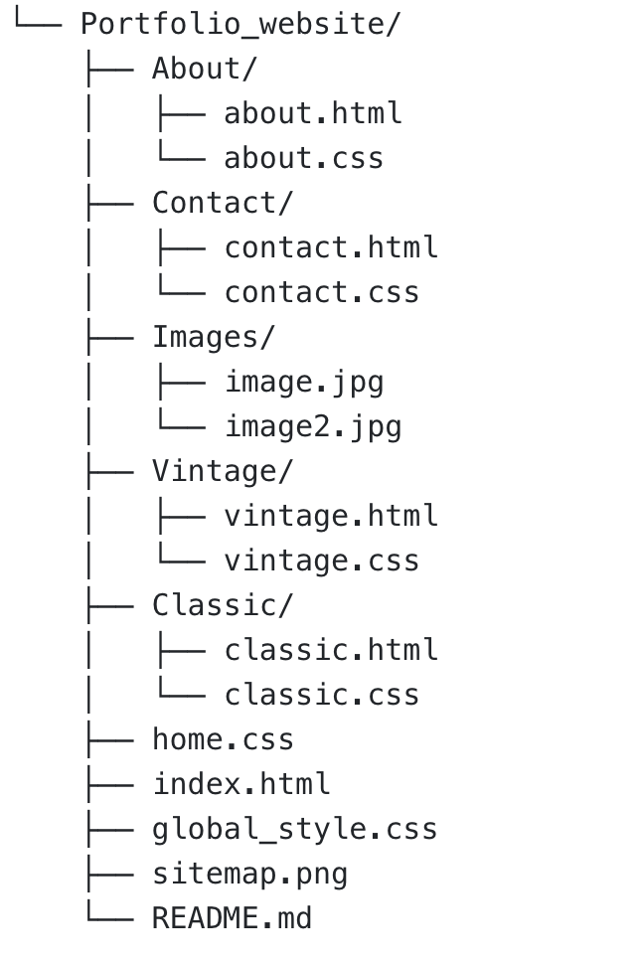**Folder Structure**In organising my files, I created the following folder structure:  
**About:** Contains both the html & CSS files for the about page.  
**Contact:** Contains the html & CSS files for the contact page.  
**Classic:** This is for the html & CSS files for the classic page.  
**Vintage:** This is for the html & CSS files for the vintage page.  
**Images:** All images are placed in this folder.  
The home page (index.html), home.css and the global style (global_style.css) are in the root of the project.

**Tools & Technologies  
Html:** I am using html as the markup language.

**CSS:** Cascading Style Sheet (CSS) is used to style the appearance of the website. This is just the plain CSS3 and no framework, e.g. Bootstrap or SASS, will be used.

**CSS Approach:** Mobile-first is the approach adopted for the styling of the pages. With this approach, all styling fit well into mobile and small devices. My thinking behind this is that it is generally believed that majority of web users, around 54%, do so using their mobile devices rather the desktop (<https://www.browserstack.com/guide/how-to-implement-mobile-first-design> ).

**Media Query:** To cater for users with large screens, media query is used on each page to make it adapted for such screen.

**JavaScript:** No JavaScript is used for this project.

**IDE:**  I will be using the Visual Studio Code for this project. VS Code is very simply to use. It has a lot of in-built solutions like the IntelliSense, code format and code colouring that aid quick and easy programming.

**Constraints/Challenges:  
Problem:** One of the main challenges faced with this website is the inability to have one single page for main common areas like the head, navigation and footer.

**Solution:** The same header/footer/navigation had to be copied across from the Home page to the other three pages to maintain consistency. This would have been avoided if any of the frameworks like Vue, React or Angular was used as single-page application.  
  
**Viewport Responsiveness**

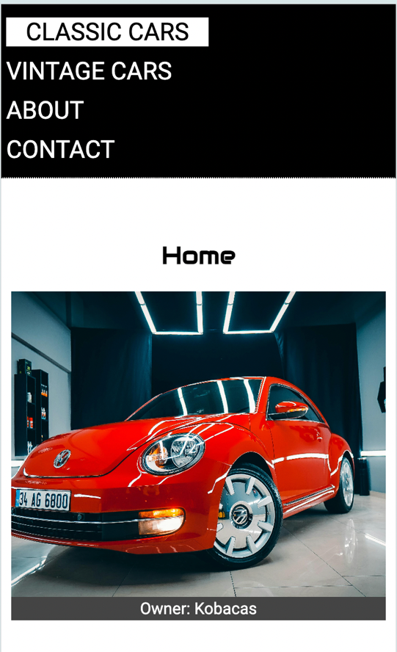**Home page – Mobile:**

**Home page – Desktop/Tablet:**  
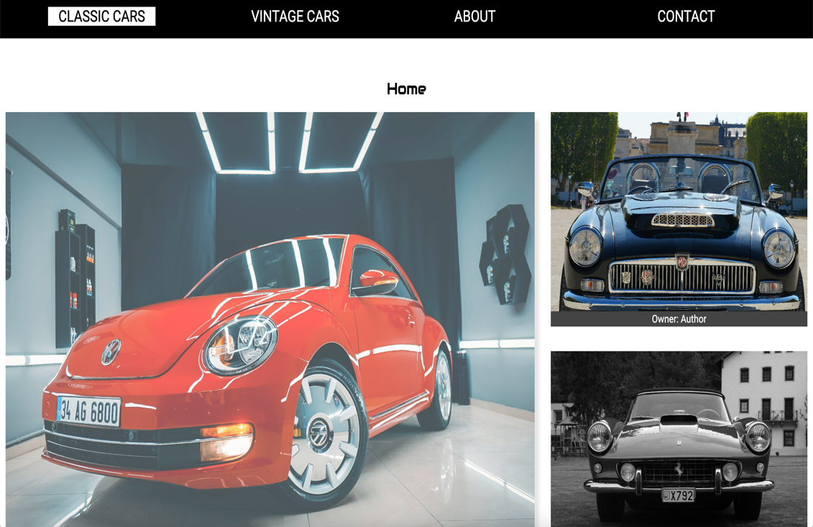

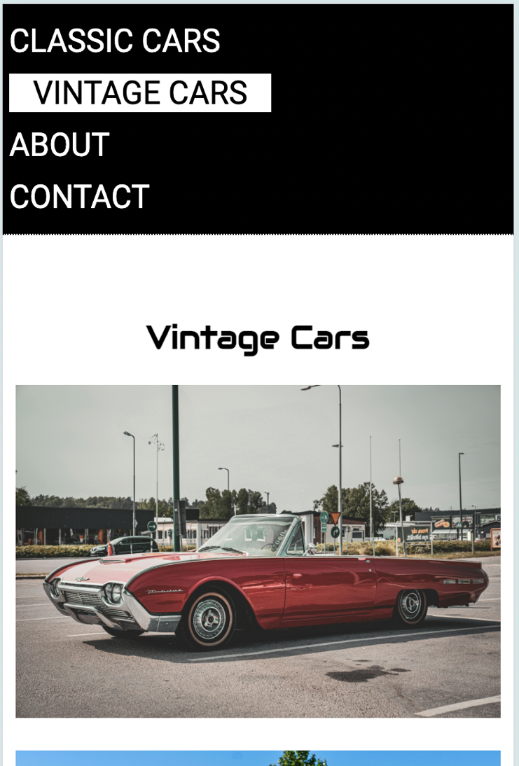  
**Vintage page - Mobile**

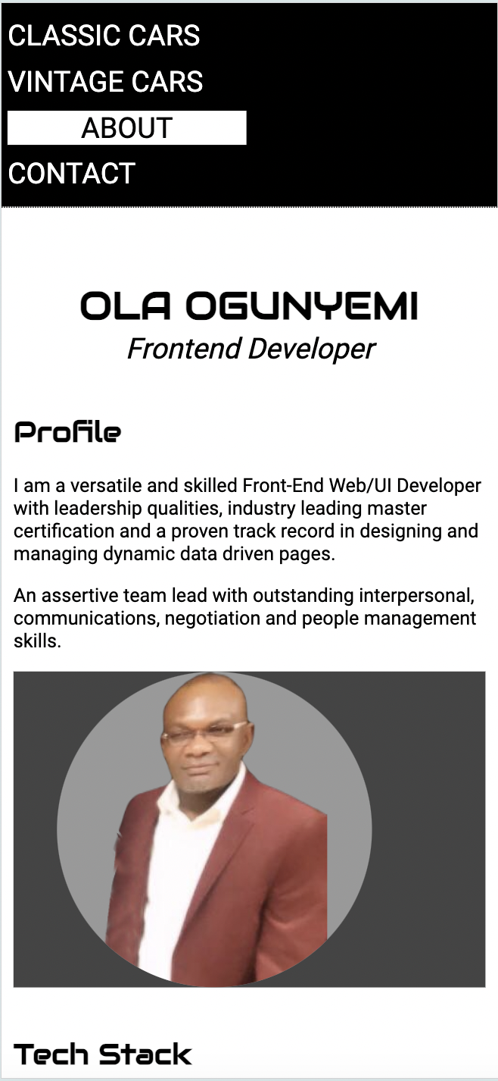**Vintage page - Desktop/Tablet:**  
  
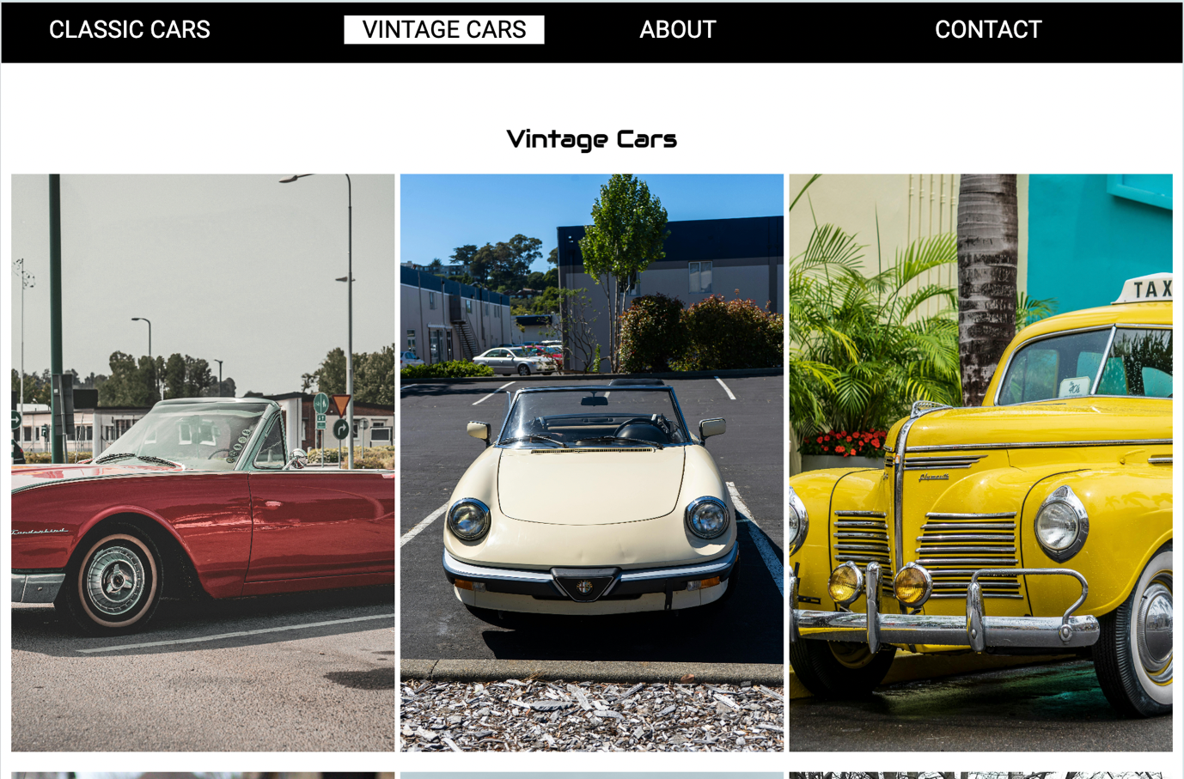**About page - Mobile**

**About page – Desktop/Tablet:**

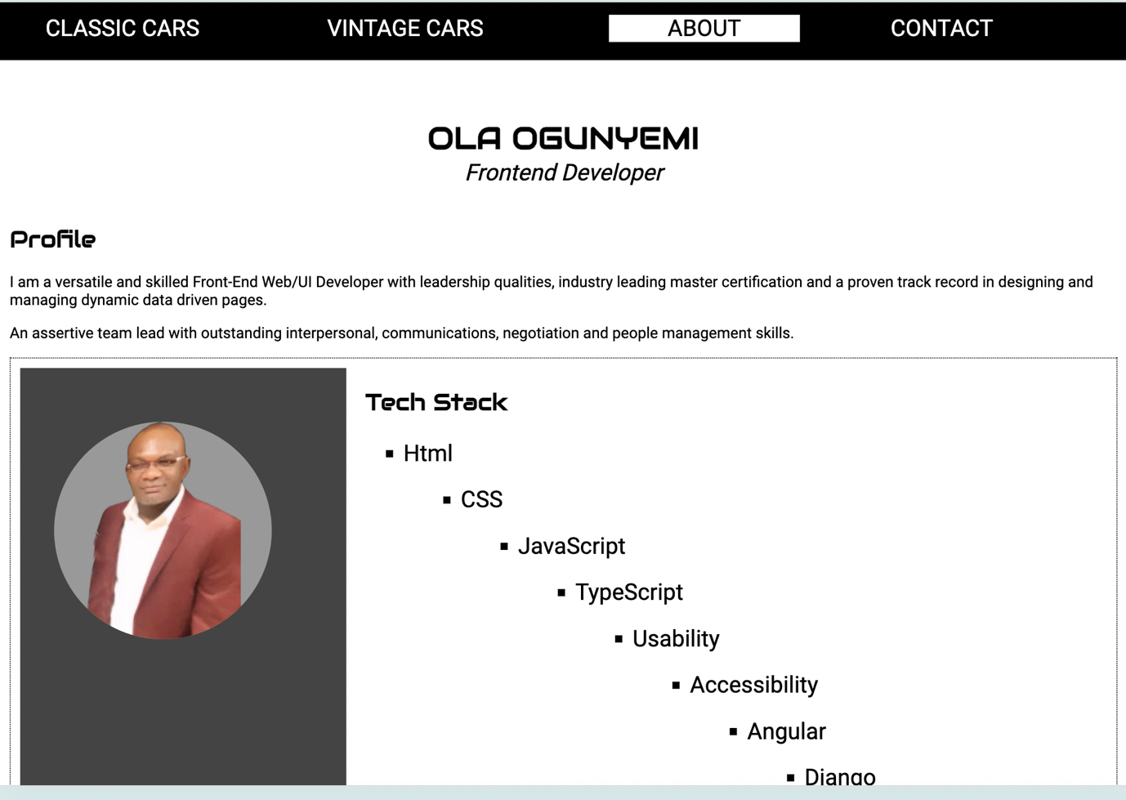

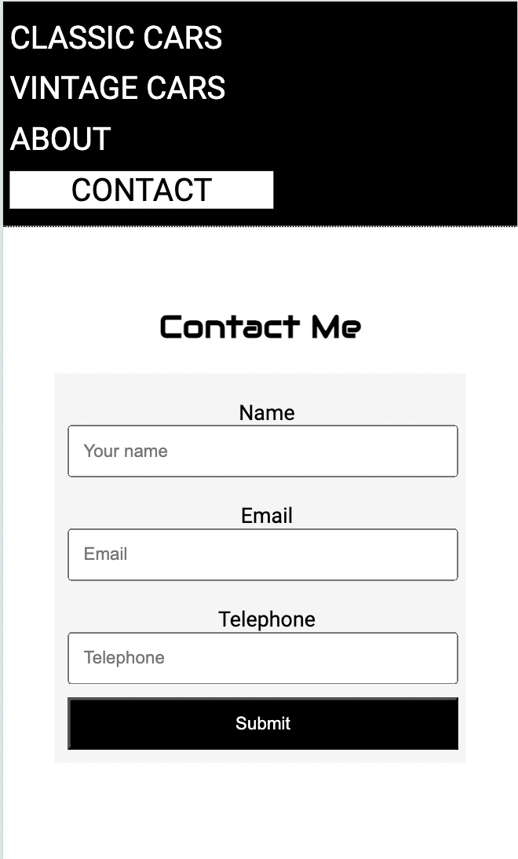**Contact – Mobile**

**Contact – Desktop/Tablet:**

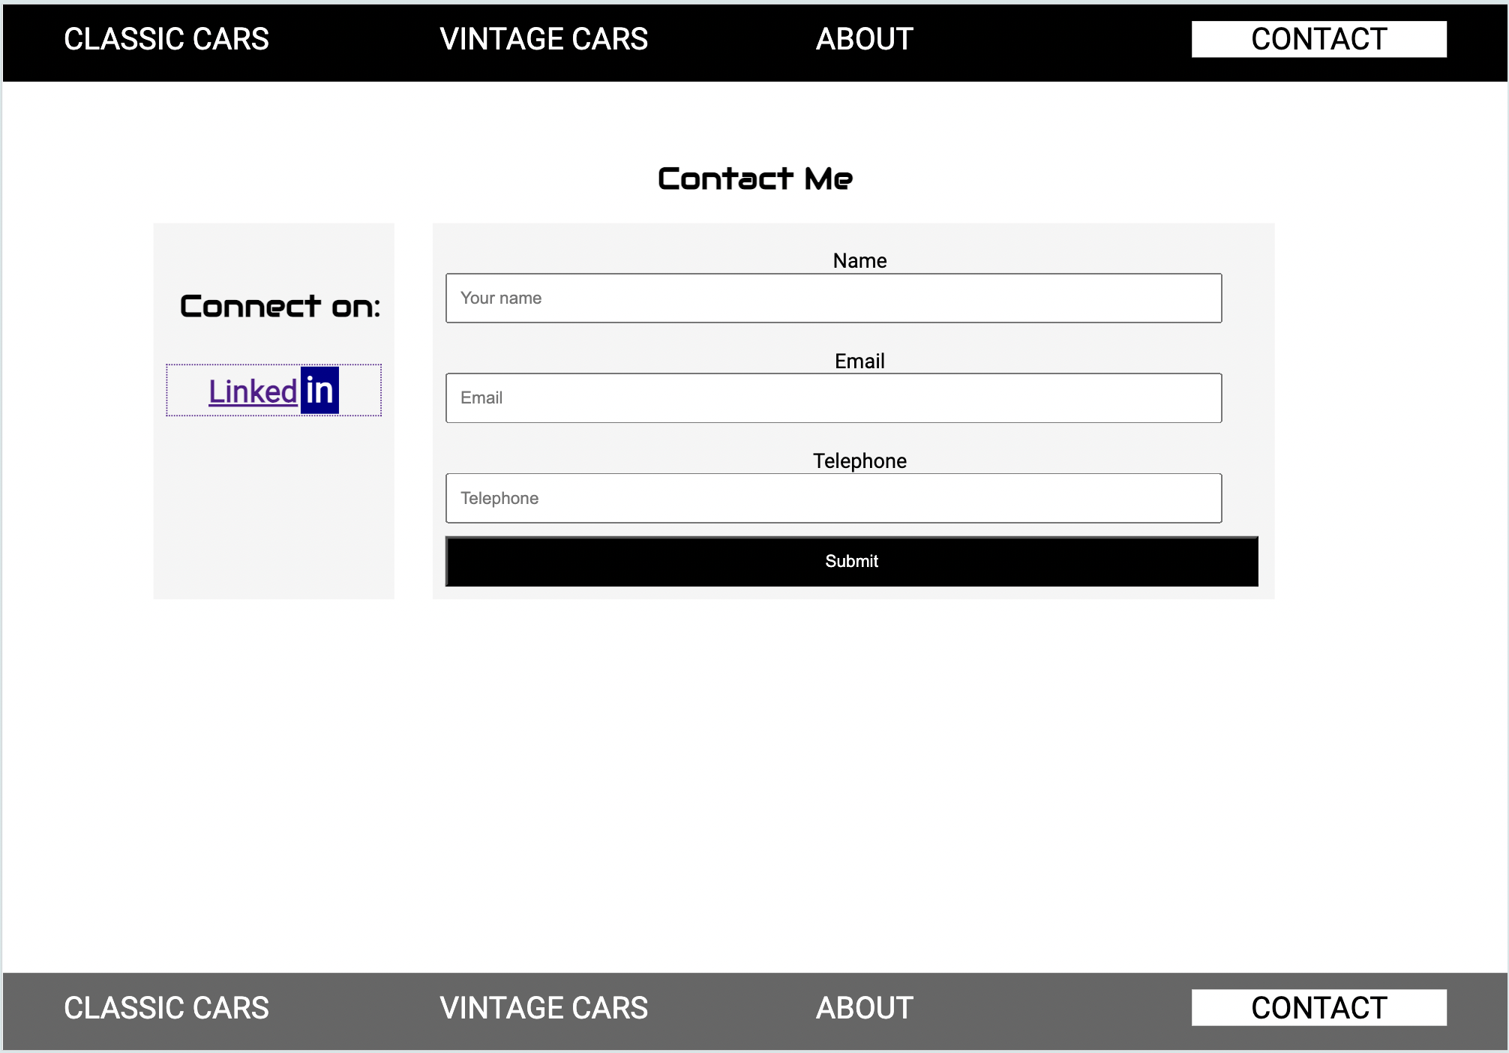

**HTML Validation Results  
Home page (Index.html)**  
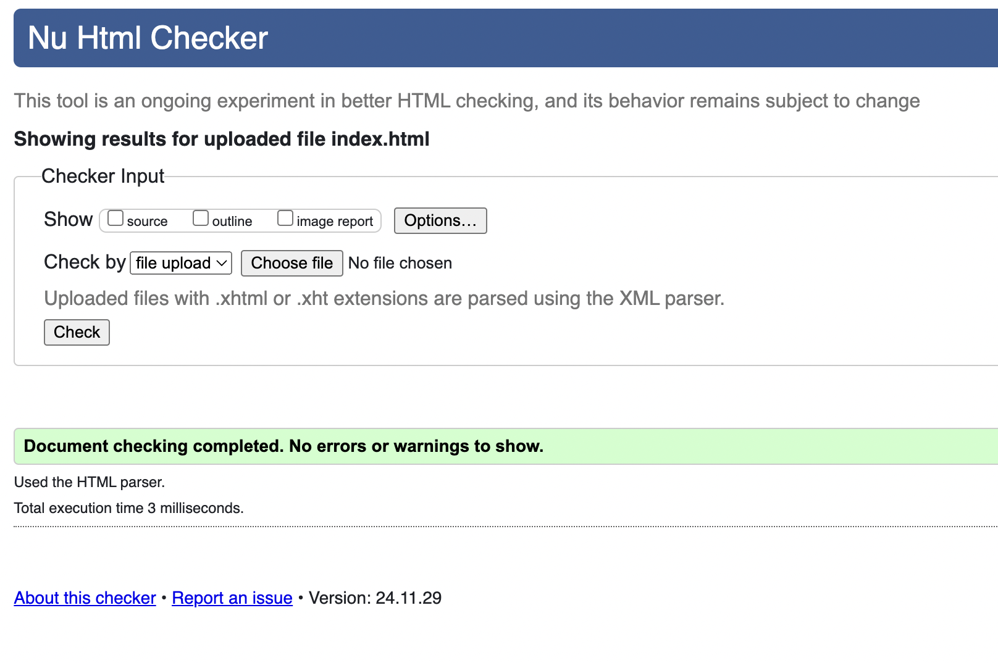

**Vintage (vintage.html**

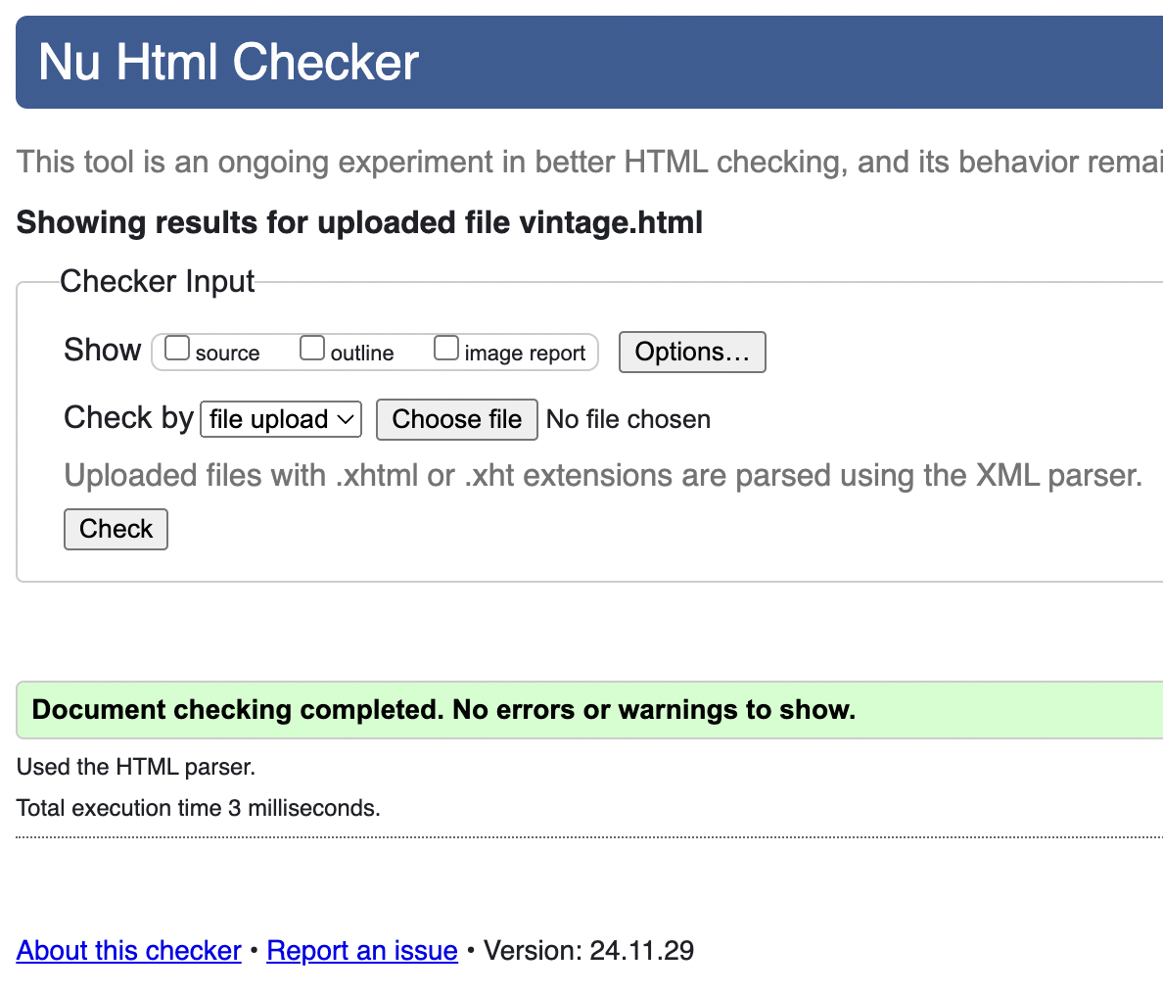

**Accessibility Test Results**

**Waves Test:**

Vintage page

**About (about.html)  
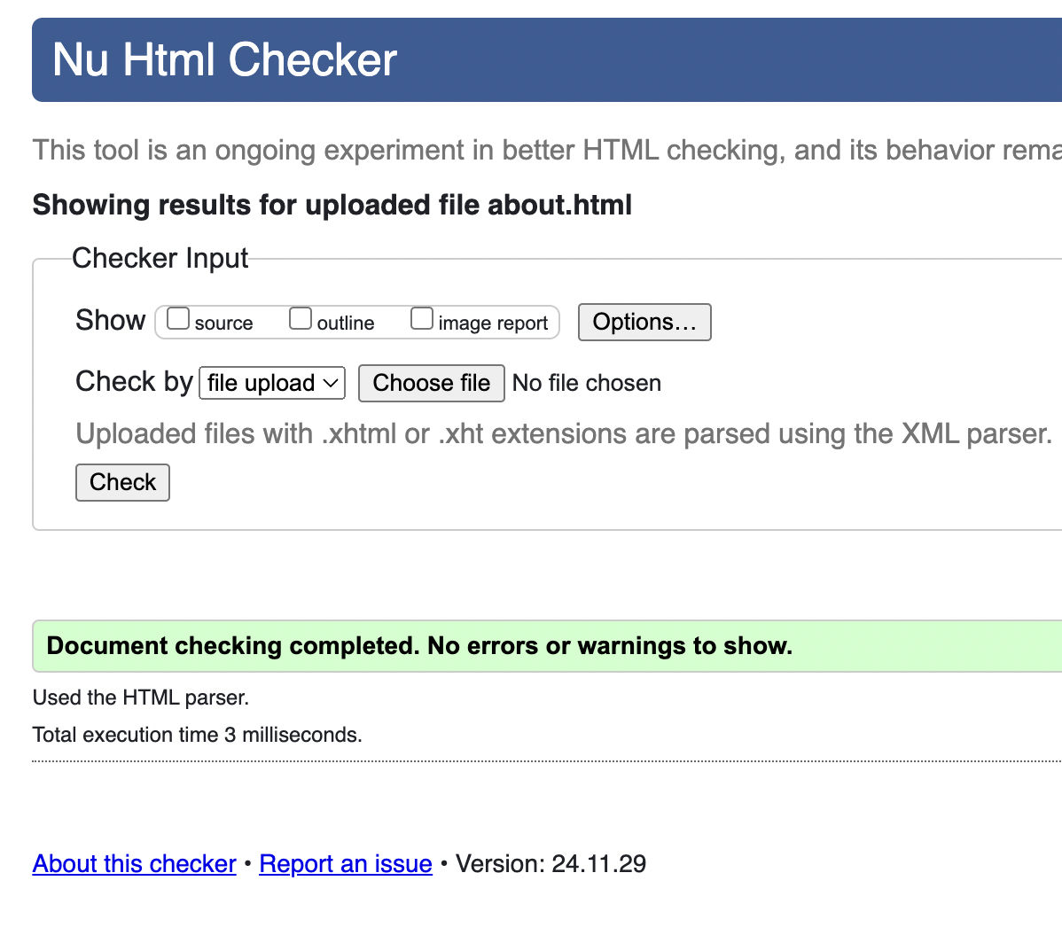**

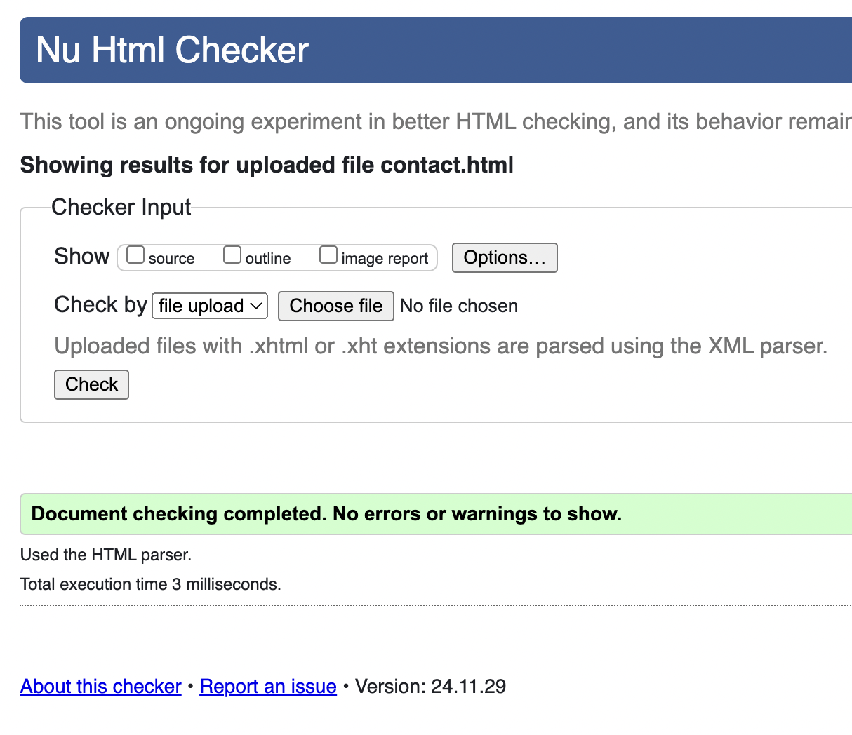**Contact (contact.html)**

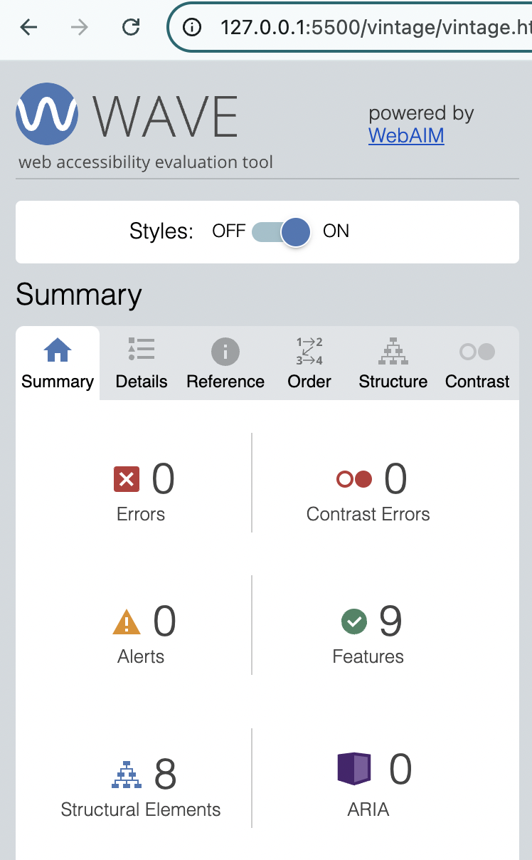**Accessibility Test – WAVE  
Home page** **Vintage page  
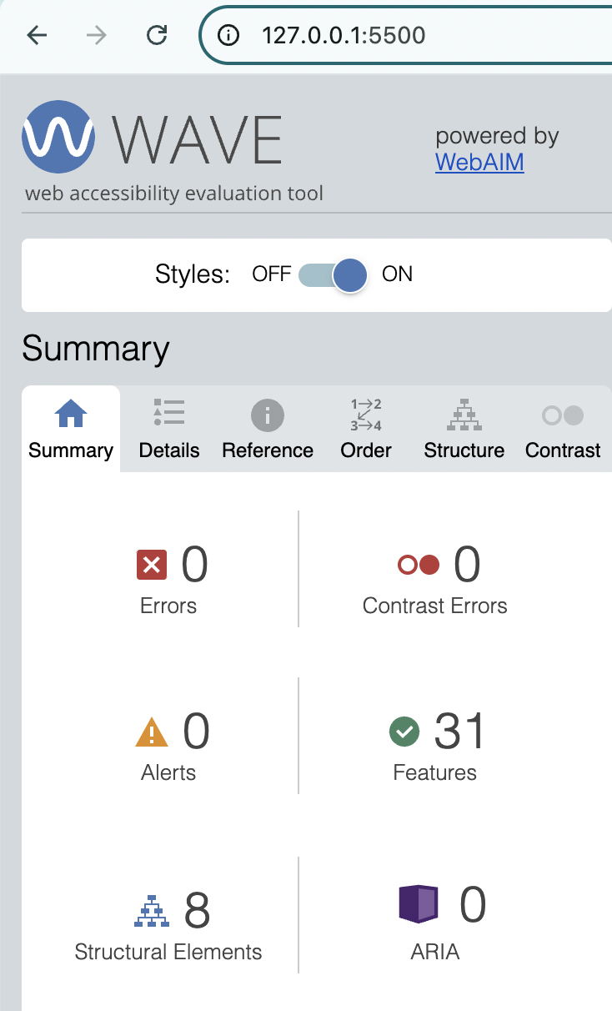**

**About page** **Contact page**

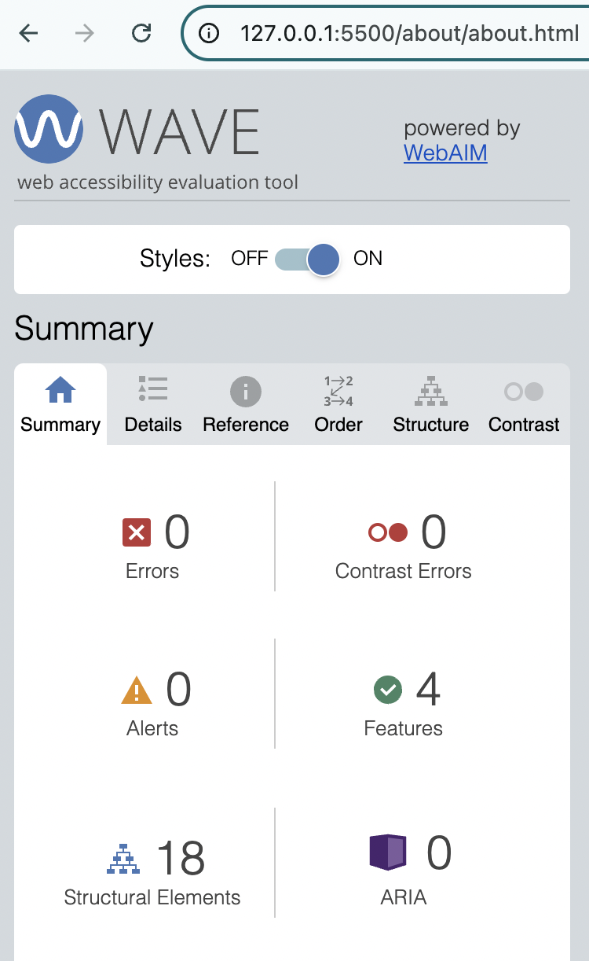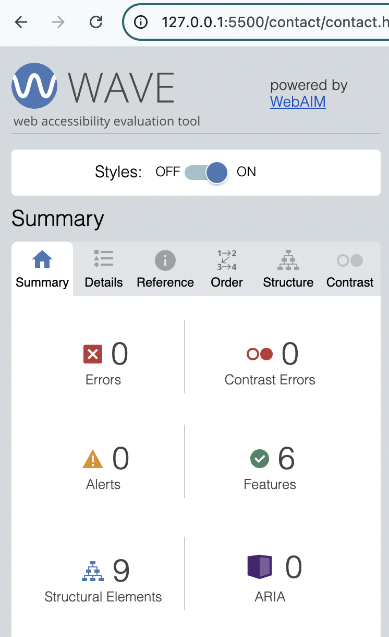

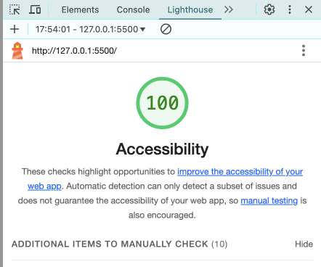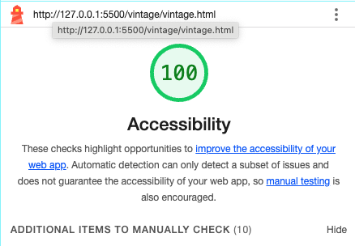**Lighthouse Accessibility Test  
Home page:** **Vintage Cars page:**

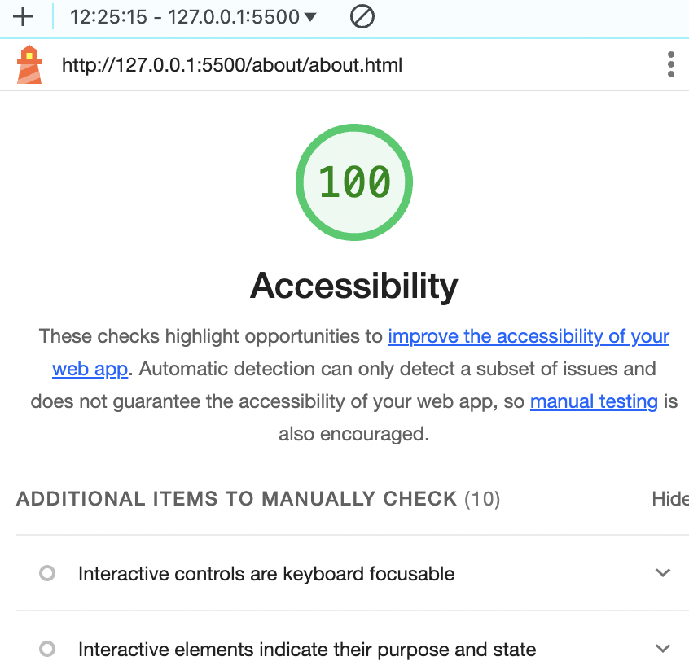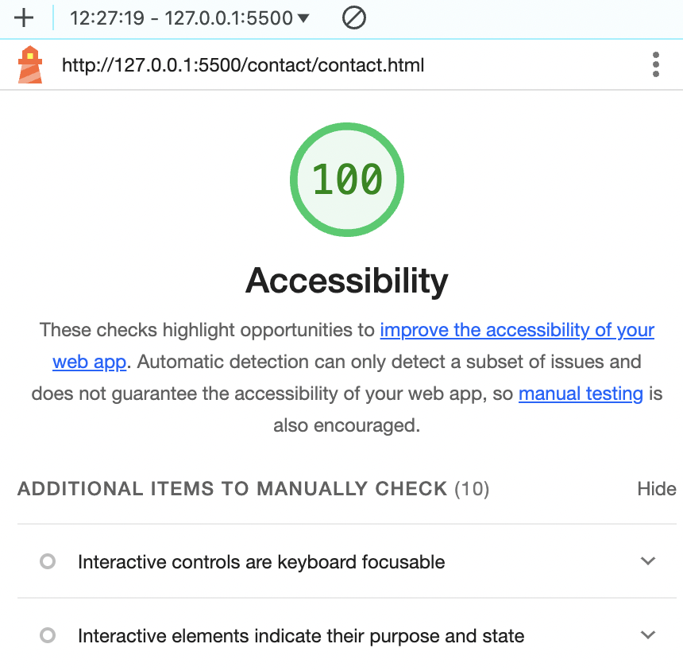**About page** **Contact page**

**Conclusion**Designing this Portfolio website has been a rewarding and engaging experience. I am, although, not new to web development and the technology but the experience that I gained during the first phase of this course has been very encouraging, especially with accessibility and usability.  
  
With the second phase in sight, I am confident to more professional improvements will be applied to this project.

**References**

1. W3C Recommendation (21st September 2023) *Web Content Accessibility Guidelines (WCAG)2.1.* Available at: <https://www.w3.org/TR/WCAG21> (Accessed: 02 December 2024).
2. Sarah Daily (5th May 2022) *Contributor for Google Fonts*Available at: <https://m3.material.io/blog/roboto-flex> (Accessed: 02 December 2024).
3. Mobile First Design (18th May 2023) *What it is and How to Implement it*Available at: <https://www.browserstack.com/guide/how-to-implement-mobile-first-design> (Accessed: 02 December 2024).

**Appendixes   
Sitemap**

